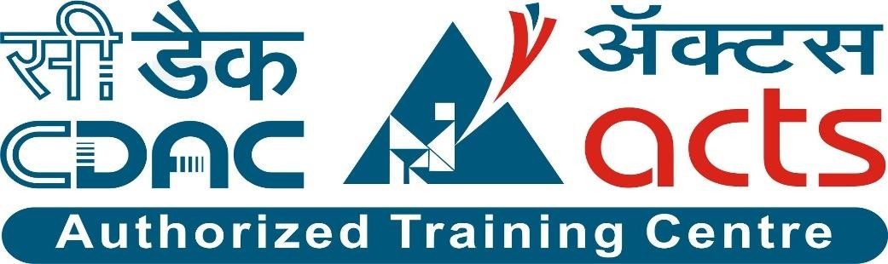

Project Name: “AgroConnect – Farmer Support and Market Linkage Platform”

Branch PG-DAC Feb-2025

Documentation On

**“AgroConnect – Farmer Support and Market Linkage Platform”**

PG-DAC February 2025

**Guided By: Bakul Joshi**

Submitted By:

**Group No: 09**

* **Saiviraj Naik 250243020080**
* **Suraj Kiswe 250243020046**
* **Om Biradar 250243020014**
* **Utkarsh Patankar 250243020063**

**Table of Contents**

1. Introduction 1

1.1 Document Purpose 1

1.2 Project Background 1

1.3 Aim & Objective 1

1.4 Customers and Stakeholders 1

2. Business Requirements Overview 2

3. Functional Requirements Overview 2

3.1 Admin Module: 2

3.2 Farmer Module: 2

3.3 Government Module: 2

3.4 Vendor Module: 2

4.Non-Functional Requirement 3

5.Use Case Diagram 3

6.Database Design 8

8.Snapshots: 14

9. Conclusion 25

# 1. Introduction

## **1.1 Document Purpose**

This document defines the business requirements and scope for developing the AgroConnect – Farmer Support System. It specifies the functional and non-functional requirements, business rules, and constraints necessary to design and implement a centralized platform connecting farmers, government agencies, vendors, and administrators. The purpose is to ensure all stakeholders have a clear understanding of the system’s objectives and expected capabilities, enabling effective planning, development, and deployment..

## **1.2 Project Background**

## There is a growing need for a unified digital platform that supports farmers in accessing agricultural resources, government schemes, and reliable market information. Farmers often face challenges in obtaining timely updates, and affordable farming tools due to the lack of centralized, accessible solutions. AgroConnect aims to address this gap by providing a comprehensive and farmer-friendly platform that connects farmers with government agencies, and vendors, thereby enhancing productivity, awareness, and access to agricultural benefits.

## **1.3 Aim & Objective**

The aim is to develop a user-friendly, web-based Farmer Support System that connects farmers with government schemes, agricultural resources, and vendors, enabling them to enhance productivity and access benefits efficiently.

* Develop a user-friendly web-based application accessible to farmers, government officials, and vendors.
* Allow farmers to register, view, and apply for government schemes.
* Enable eligibility verification based on farmer income and land size.
* Provide a marketplace for vendors to offer farming equipment, seeds, and fertilizers for sale or rent.
* Allow government officials to add, update, and manage agricultural schemes.
* Facilitate communication between farmers, government bodies, and vendors.
* Provide timely notifications for scheme updates, deadlines, and farming tips.
* Ensure data security, scalability, and system reliability for rural and semi-urban usage.

## **1.4 Customers and Stakeholders**

* **Customers:**
* Farmers seeking access to government schemes, rent or purchase farming equipment, seeds, and fertilizers

.

* Government officials responsible for managing agricultural welfare programs.
* Vendors offering agricultural products and machinery.
* **Stakeholders:**
* Farming community and agricultural cooperatives.
* Government agriculture departments and extension officers.
* Vendors and suppliers in the agricultural sector.
* System administrators (Admin) responsible for user management, content moderation, and platform maintenance.

# 2. Business Requirements Overview

**Target platform:** Web-based application accessible via desktop and mobile browsers.

**User interface:** Simple, intuitive, and farmer-friendly design optimized for rural and semi-urban users with limited technical experience.

**Primary users:** Farmers, Government Officials, Vendors, and Administrators.

**Core features:** Scheme management, eligibility verification, farmer applications, vendor marketplace, and secure user authentication.

# 3. Functional Requirements Overview

## 1. Admin Module

## 2. Farmer Module

## 3. Government Module

## 4. Vendor Module

**3.1 Admin Module:**

* Manage users (Farmers, Vendors, Government Officials).
* Monitor interactions and system usage.
* Approve or deactivate user accounts when necessary.
  1. **Farmer Module:**
* Farmer registration and login.
* View and search government schemes.
* Apply for eligible schemes based on income and land size criteria.
* View scheme updates, deadlines, and agricultural tips.
* Access vendor marketplace for renting or purchasing agricultural equipment, seeds, and fertilizers.

**3.3 Government Module:**

* Government official registration and login.
* Add, update, and manage agricultural schemes.
* Define eligibility criteria (income, land size, etc.) for schemes.
* View and manage farmer applications for schemes.

**3.4 Vendor Module:**

* + Vendor registration and login.
  + List agricultural equipment for rent.
  + List seeds, fertilizers, and other farming inputs for sale.
  + Manage product listings, pricing, and availability.
  + View and manage farmer purchase/rental requests.

# 4.Non-Functional Requirement

* **Performance:** The application should be responsive, load quickly, and handle a high volume of concurrent users without performance degradation.
* **User Experience:** Provide a clean, intuitive, and responsive interface accessible to users of all digital literacy levels.
* **Security:** Ensure secure user authentication, data encryption, and role-based access control to protect sensitive information.
* **Availability:** Ensure 24/7 system access with minimal downtime and high reliability.

# 5.Use Case Diagram

1. **Admin:**

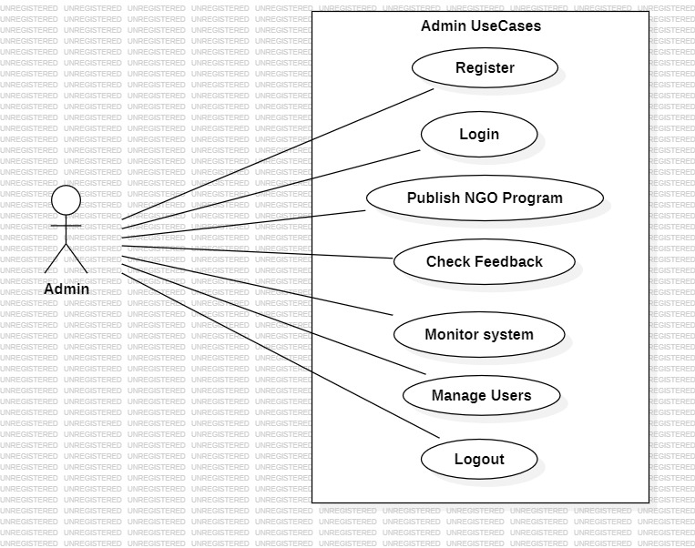

**Admin:**

1. **In the Admin use case diagram, Admin is the Actor.**
2. **Admin can handle the following use cases:  
   a. Login  
   b. Manage users (Farmers, Vendors, Government Officials)  
   c. Monitor and moderate platform activities  
   d. Approve or deactivate user accounts**

1. **Farmer:**

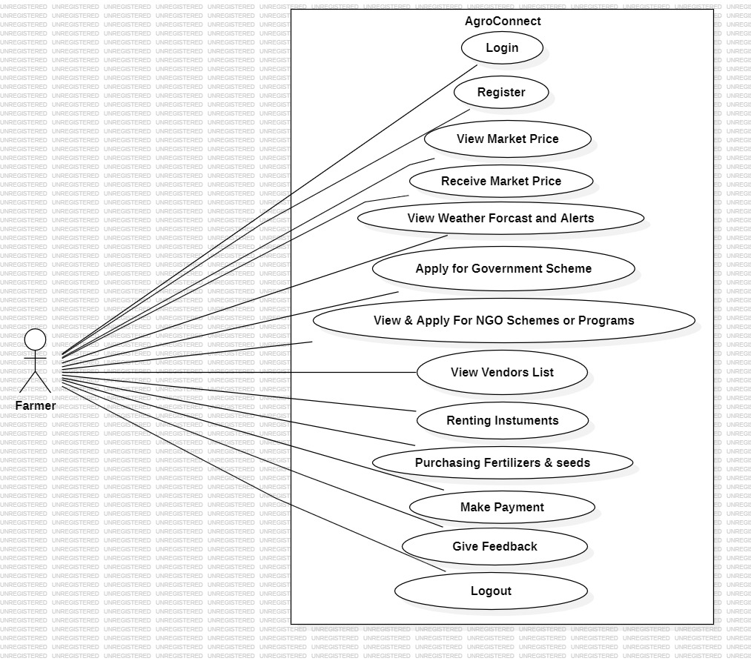

**Farmer:**

1. **In the Farmer use case diagram, Farmer is the Actor.**
2. **Farmer can handle the following use cases:  
   a. Register  
   b. Login   
   c. View available government schemes  
   d. Apply for eligible schemes based on criteria  
   e. View application history and status  
   f. Access vendor marketplace for renting or purchasing farming equipment, seeds, and fertilizers  
   g. View about scheme updates, deadlines, and agricultural tips**

1. **Government:**

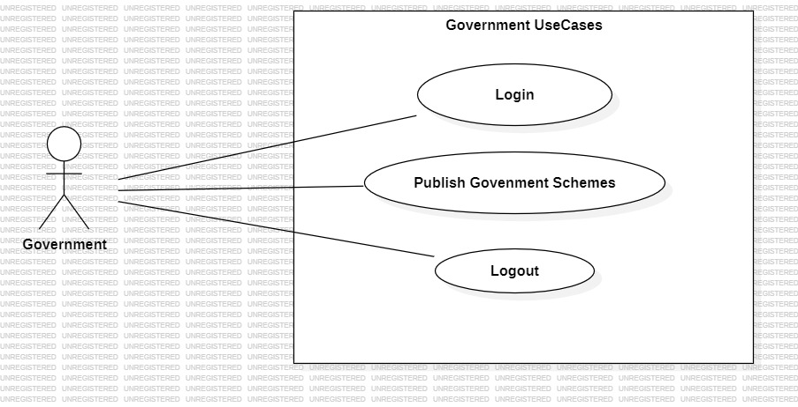

**Government:**

1. **In the Government use case diagram, Government Official is the Actor.**
2. **Government Official can handle the following use cases:  
   a. Login  
   b. Create and manage agricultural schemes  
   c. Define eligibility criteria for schemes  
   d. View list of farmers who have applied for schemes  
   e. Review and update the status of farmer applications**

1. **Vendor:**

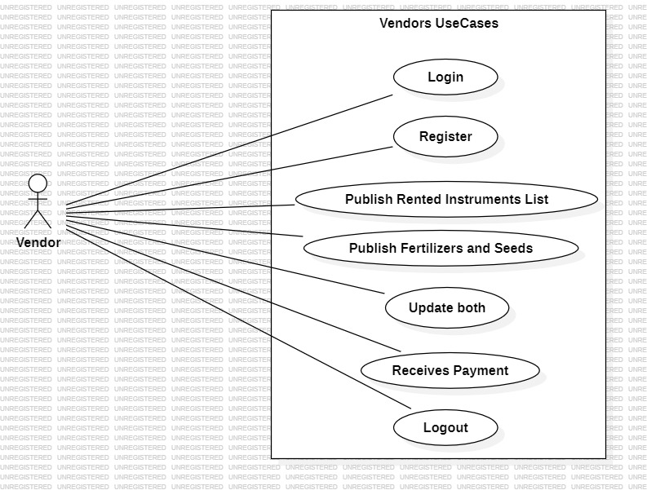

**Vendor:**

1. **In the Vendor use case diagram, Vendor is the Actor.**
2. **Vendor can handle the following use cases:  
   a. Login  
   b. Add and manage product listings (farming equipment, seeds, fertilizers)  
   c. Update product details such as price, and description**

# 6.Database Design (Tables Structure) :

## **I. Role****:**

|  |  |  |  |  |  |
| --- | --- | --- | --- | --- | --- |
| **Field** | **Type** | **Null** | **Key** | **Default** | **Extra** |
| rid | int | NO | PK |  | auto_increment |
| rname | varchar(100) | NO |  |  |  |

## **II. Users:**

|  |  |  |  |  |  |
| --- | --- | --- | --- | --- | --- |
| **Field** | **Type** | **Null** | **Key** | **Default** | **Extra** |
| uid | int | NO | PK |  | auto_increment |
| username | varchar(100) | NO |  |  |  |
| password | varchar(255) | NO |  |  |  |
| rid | int | NO |  |  |  |
| mobileno | varchar(15) | NO |  |  |  |
| email | varchar(45) | NO |  |  |  |
| fname | varchar(45) | NO |  |  |  |
| lname | varchar(45) | NO |  |  |  |
| status | tinyint | NO |  |  |  |

## **III. Vendors:**

|  |  |  |  |  |  |
| --- | --- | --- | --- | --- | --- |
| **Field** | **Type** | **Null** | **Key** | **Default** | **Extra** |
| vid | int | NO | PK |  | auto_increment |
| uid | int | NO |  |  |  |
| liscenceno | varchar(45) | NO |  |  |  |
| companyname | varchar(45) | NO |  |  |  |

## **IV. Farmer:**

|  |  |  |  |  |  |
| --- | --- | --- | --- | --- | --- |
| **Field** | **Type** | **Null** | **Key** | **Default** | **Extra** |
| fid | int | NO | PK |  | auto_increment |
| uid | int | YES |  | NULL |  |
| landsize | double | NO |  |  |  |
| income | double | NO |  |  |  |
| locid | int | NO |  |  |  |

## **V. Government:**

|  |  |  |  |  |  |
| --- | --- | --- | --- | --- | --- |
| **Field** | **Type** | **Null** | **Key** | **Default** | **Extra** |
| gid | int | NO | PK |  | auto_increment |
| uid | int | NO |  |  |  |
| empno | int | NO |  |  |  |
| deptname | varchar(45) | NO |  |  |  |
| designation | varchar(45) | NO |  |  |  |

## **VI. Appliedscheme:**

|  |  |  |  |  |  |
| --- | --- | --- | --- | --- | --- |
| **Field** | **Type** | **Null** | **Key** | **Default** | **Extra** |
| aid | int | NO | PK |  |  |
| gid | int | NO |  |  |  |
| fid | int | NO |  |  |  |
| status | tinyint | NO |  |  |  |
| schemeid | int | NO |  |  |  |

## **VII. Bankaccount:**

|  |  |  |  |  |  |
| --- | --- | --- | --- | --- | --- |
| **Field** | **Type** | **Null** | **Key** | **Default** | **Extra** |
| accid | int | NO | PK |  | auto_increment |
| accno | varchar(45) | NO |  |  |  |
| bankname | varchar(45) | NO |  |  |  |
| branchname | varchar(45) | NO |  |  |  |
| ifsccode | varchar(45) | NO |  |  |  |

## **VIII. Brands:**

|  |  |  |  |  |  |
| --- | --- | --- | --- | --- | --- |
| **Field** | **Type** | **Null** | **Key** | **Default** | **Extra** |
| bid | int | NO | PK |  | auto_increment |
| bname | varchar(65) | NO |  |  |  |
| cid | int | NO |  |  |  |

## **IX. Cart:**

|  |  |  |  |  |  |
| --- | --- | --- | --- | --- | --- |
| **Field** | **Type** | **Null** | **Key** | **Default** | **Extra** |
| cartid | int | NO | PK |  | auto_increment |
| fid | int | NO |  |  |  |
| quantity | int | YES |  | '1' |  |
| duration_days | int | YES |  | NULL |  |
| pvid | int | YES |  | NULL |  |
| prorid | int | YES |  | NULL |  |
| added_date | datetime | YES |  | CURRENT_TIMESTAMP |  |
| price | double | NO |  | '0' |  |

## **X. Category:**

|  |  |  |  |  |  |
| --- | --- | --- | --- | --- | --- |
| **Field** | **Type** | **Null** | **Key** | **Default** | **Extra** |
| cid | int | NO | PK |  | auto_increment |
| cname | varchar(45) | NO |  |  |  |
| ctype | varchar(45) | NO |  |  |  |
| description | varchar(255) | NO |  |  |  |

## **XI. Feedback:**

|  |  |  |  |  |  |
| --- | --- | --- | --- | --- | --- |
| **Field** | **Type** | **Null** | **Key** | **Default** | **Extra** |
| feedid | int | NO | PK |  | auto_increment |
| uid | int | NO |  |  |  |
| vid | int | NO |  |  |  |
| message | text | YES |  |  |  |
| date | date | YES |  | NULL |  |

## **XII. Location:**

|  |  |  |  |  |  |
| --- | --- | --- | --- | --- | --- |
| **Field** | **Type** | **Null** | **Key** | **Default** | **Extra** |
| locid | int | NO | PK |  | auto_increment |
| locname | varchar(45) | NO |  |  |  |

## **XIII. Orderdetails:**

|  |  |  |  |  |  |
| --- | --- | --- | --- | --- | --- |
| **Field** | **Type** | **Null** | **Key** | **Default** | **Extra** |
| orderdetailid | int | NO | PK |  | auto_increment |
| orderid | int | NO |  |  |  |
| pvid | int | YES |  | NULL |  |
| prorid | int | YES |  | NULL |  |
| quantity | int | YES |  | '1' |  |
| durationdays | int | YES |  | NULL |  |
| priceperunit | decimal(10,2) | NO |  | '0.00' |  |
| subtotal | decimal(10,2) | NO |  | '0.00' |  |
| vid | int | YES |  | NULL |  |
| price | decimal(8,2) | YES |  | '0.00' |  |

## **XIV. Ordermaster:**

|  |  |  |  |  |  |
| --- | --- | --- | --- | --- | --- |
| **Field** | **Type** | **Null** | **Key** | **Default** | **Extra** |
| orderid | int | NO | PK |  | auto_increment |
| fid | int | NO |  |  |  |
| orderdate | datetime | YES |  | CURRENT_TIMESTAMP |  |
| totalamount | decimal(10,2) | NO |  |  |  |
| paymentstatus | varchar(20) | YES |  | 'Pending' |  |
| paymentmethod | varchar(20) | YES |  | NULL |  |
| shippingaddress | text | YES |  |  |  |

## **XV. Payment:**

|  |  |  |  |  |  |
| --- | --- | --- | --- | --- | --- |
| **Field** | **Type** | **Null** | **Key** | **Default** | **Extra** |
| paymentid | int | NO | PK |  | auto_increment |
| orderid | int | NO |  |  |  |
| amount | decimal(10,2) | NO |  |  |  |
| method | varchar(20) | NO |  | 'UPI' |  |
| paymentstatus | varchar(20) | YES |  | 'Pending' |  |
| transaction_id | varchar(50) | YES |  | NULL |  |
| payment_date | datetime | YES |  | CURRENT_TIMESTAMP |  |

## **XVI. Product:**

|  |  |  |  |  |  |
| --- | --- | --- | --- | --- | --- |
| **Field** | **Type** | **Null** | **Key** | **Default** | **Extra** |
| prodid | int | NO | PK |  | auto_increment |
| cid | int | NO |  |  |  |
| pname | varchar(100) | NO |  |  |  |
| pdescription | text | YES |  |  |  |
| bid | int | NO |  |  |  |

## **XVII. Productrental:**

|  |  |  |  |  |  |
| --- | --- | --- | --- | --- | --- |
| **Field** | **Type** | **Null** | **Key** | **Default** | **Extra** |
| prorid | int | NO | PK |  | auto_increment |
| prodid | int | NO |  |  |  |
| vid | int | NO |  |  |  |
| rateperday | decimal(10,0) | NO |  |  |  |

## **XVIII. Productvendor:**

|  |  |  |  |  |  |
| --- | --- | --- | --- | --- | --- |
| **Field** | **Type** | **Null** | **Key** | **Default** | **Extra** |
| pvid | int | NO | PK |  | auto_increment |
| prodid | int | NO |  |  |  |
| vid | int | NO |  |  |  |
| price | decimal(10,2) | YES |  | NULL |  |

## **XIX. Schemes:**

|  |  |  |  |  |  |
| --- | --- | --- | --- | --- | --- |
| **Field** | **Type** | **Null** | **Key** | **Default** | **Extra** |
| schemeid | int | NO | PK |  | auto_increment |
| schemename | varchar(45) | NO |  |  |  |
| startdate | date | NO |  |  |  |
| lastdate | date | NO |  |  |  |
| eligibility | varchar(255) | NO |  |  |  |
| description | varchar(255) | NO |  |  |  |
| gid | int | NO |  |  |  |
| income | double | NO |  |  |  |
| landsize | double | NO |  |  |  |

# 8.Snapshots:

**8.1 Home Page:**

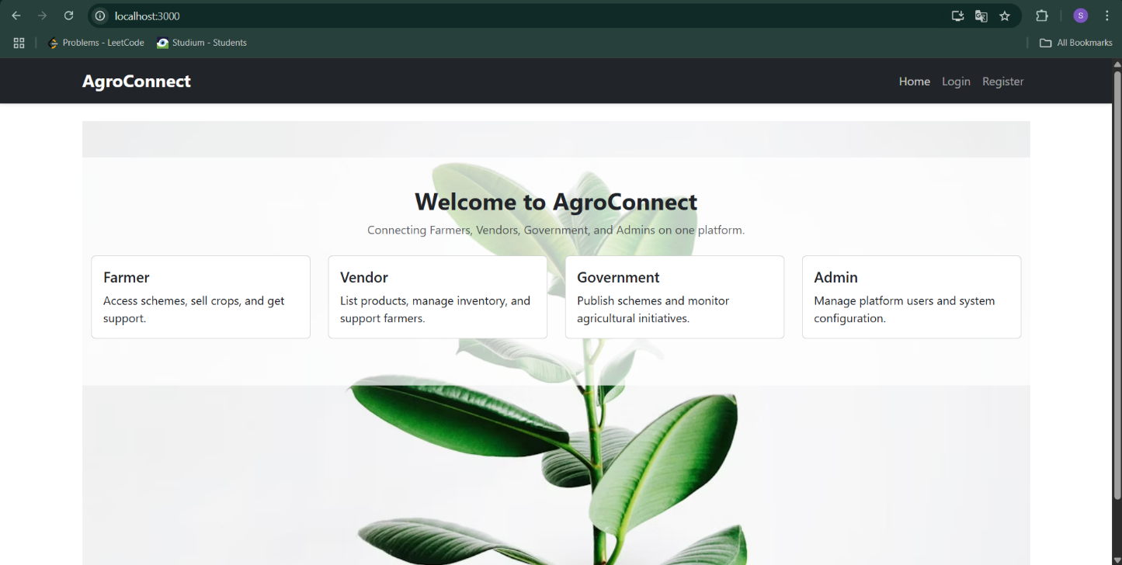

**8.2 Registration Page:**

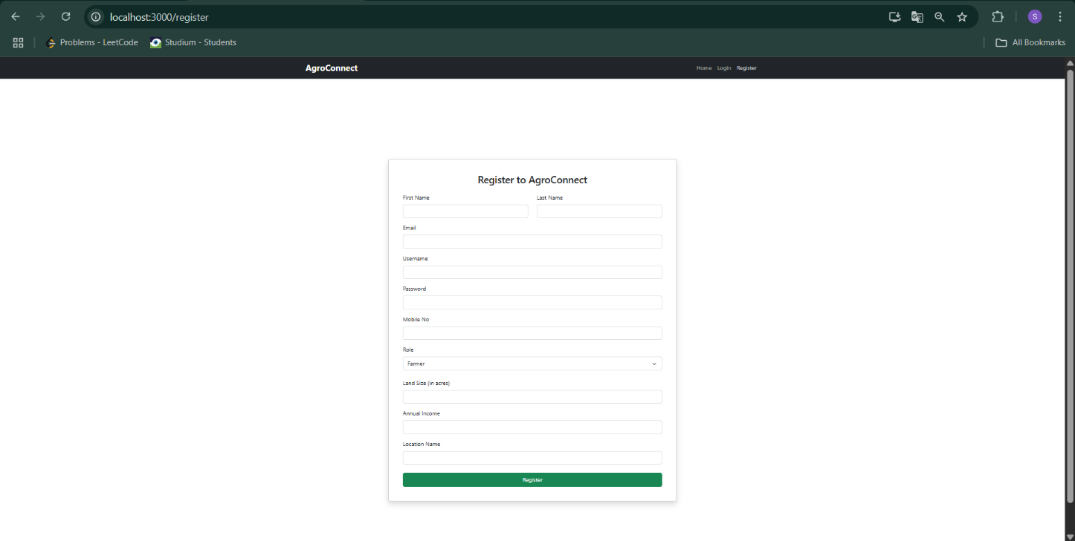

**8.3 Admin Home Page:**

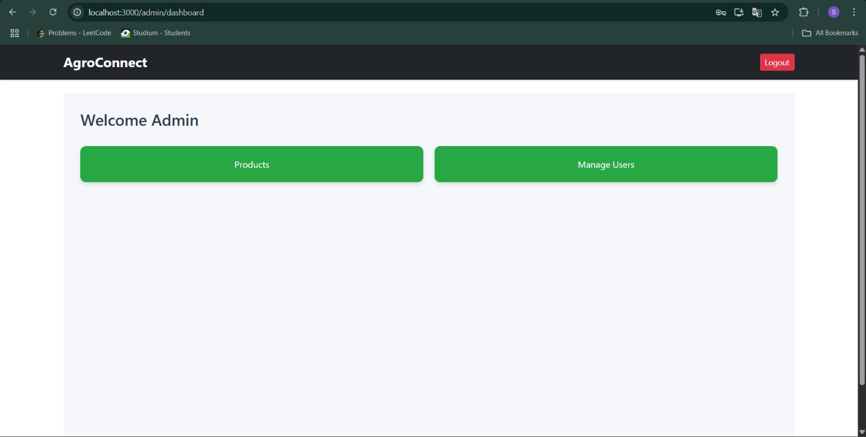

In Products:

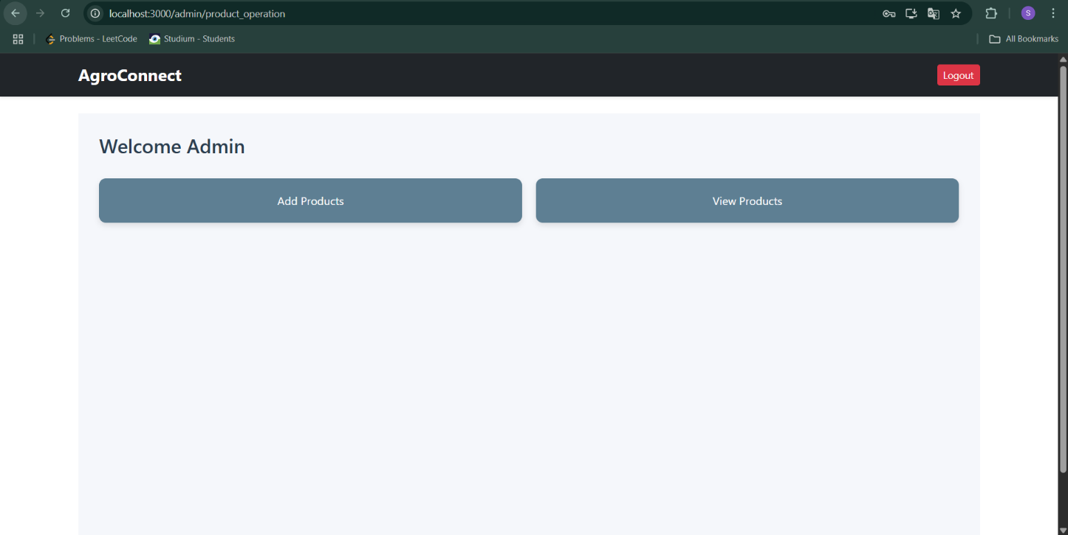

In Add products:

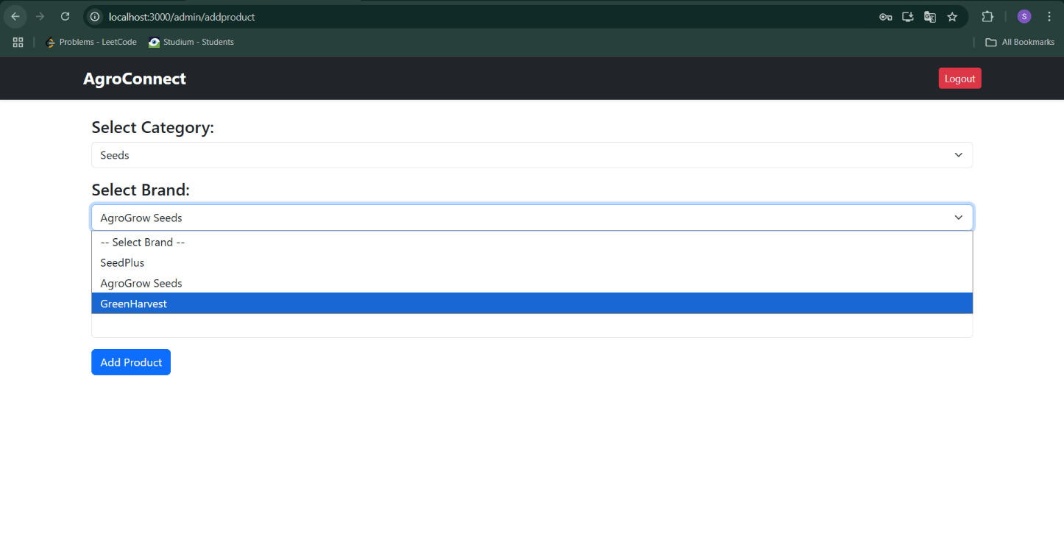

In View Products:

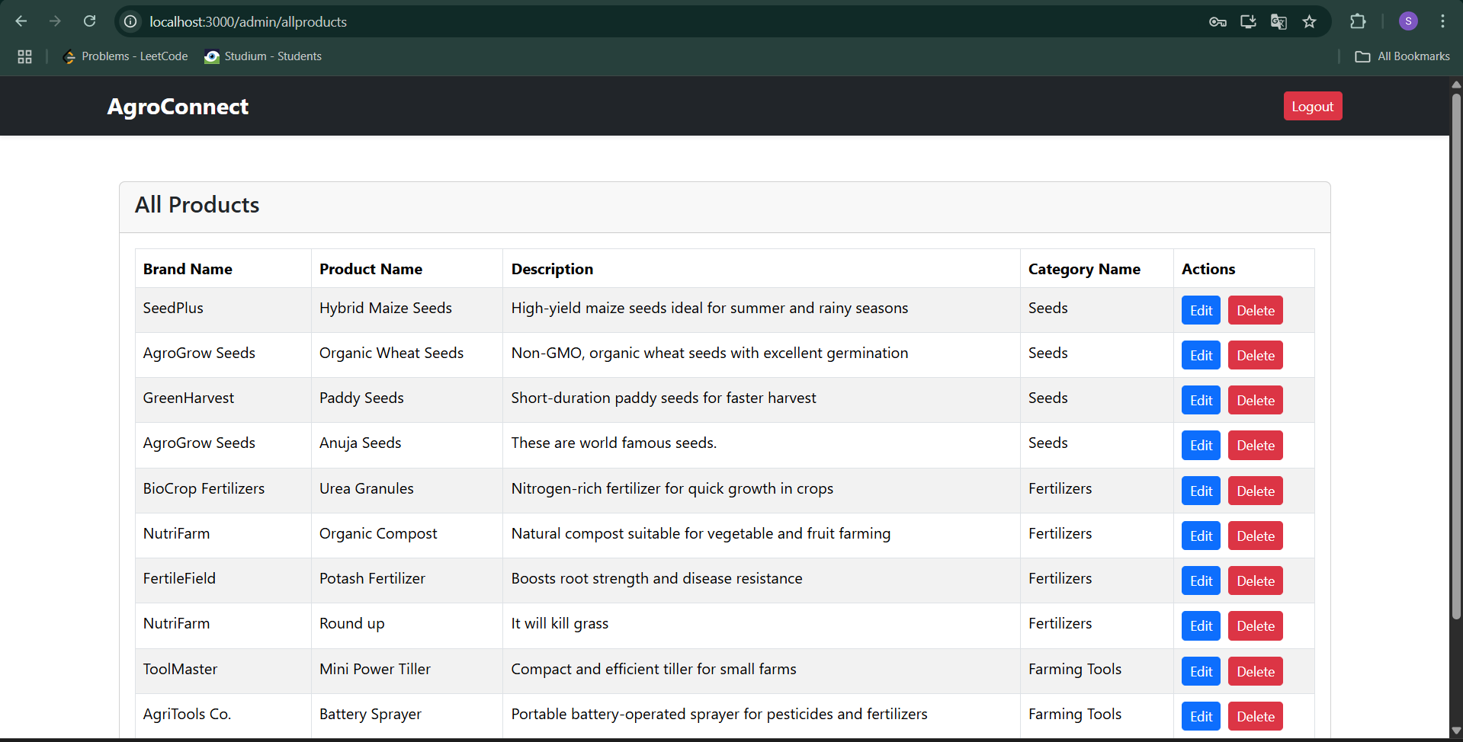

In view all users:

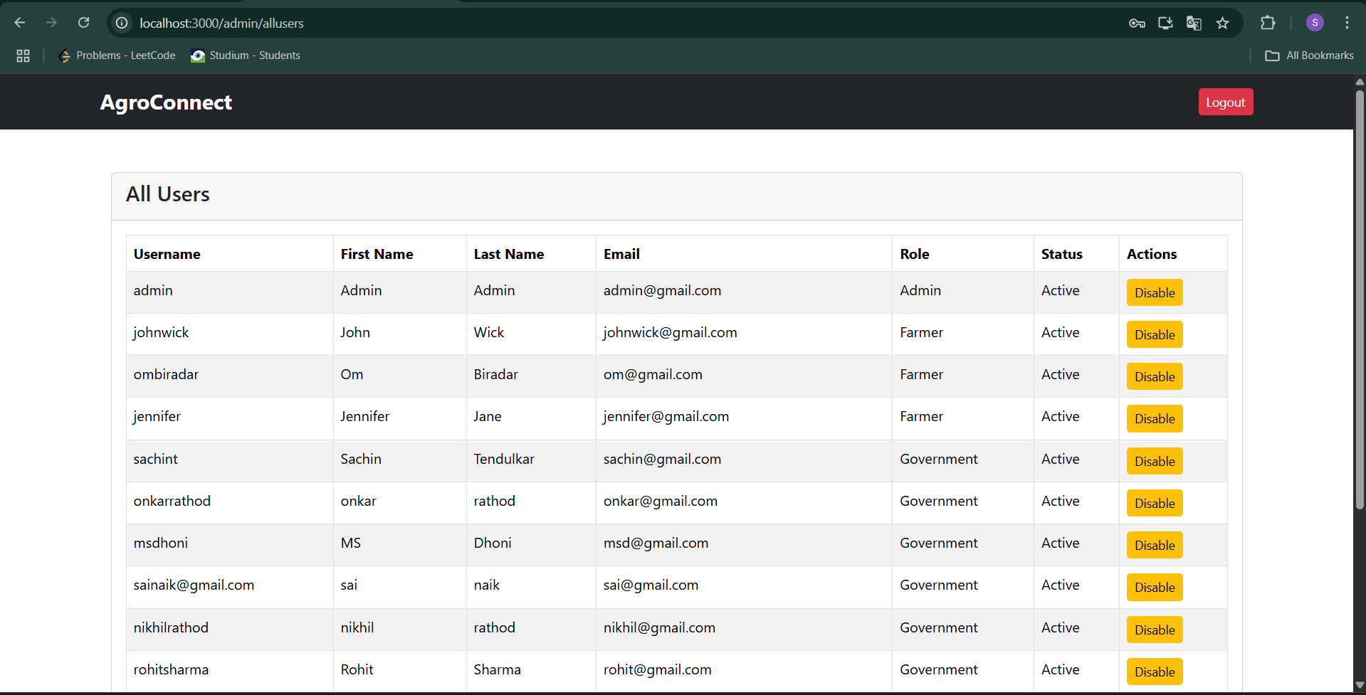

**8.4 Farmer Page**

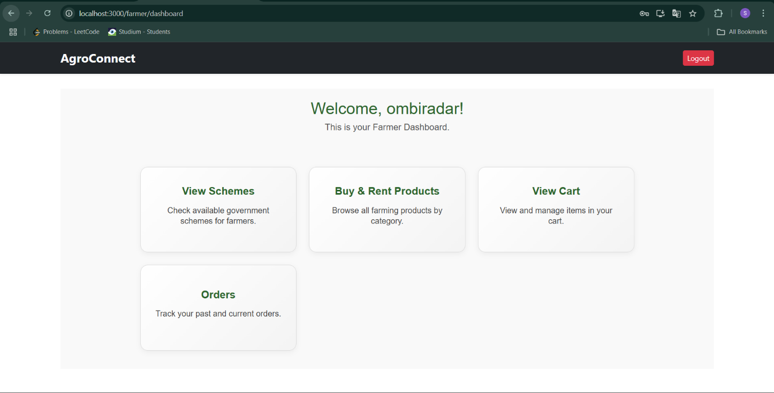

In Buy / Rent Products:

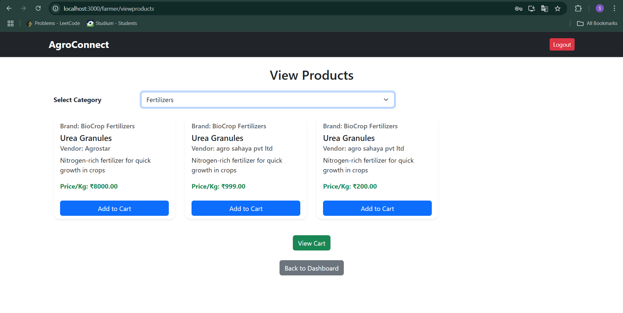

In view cart :

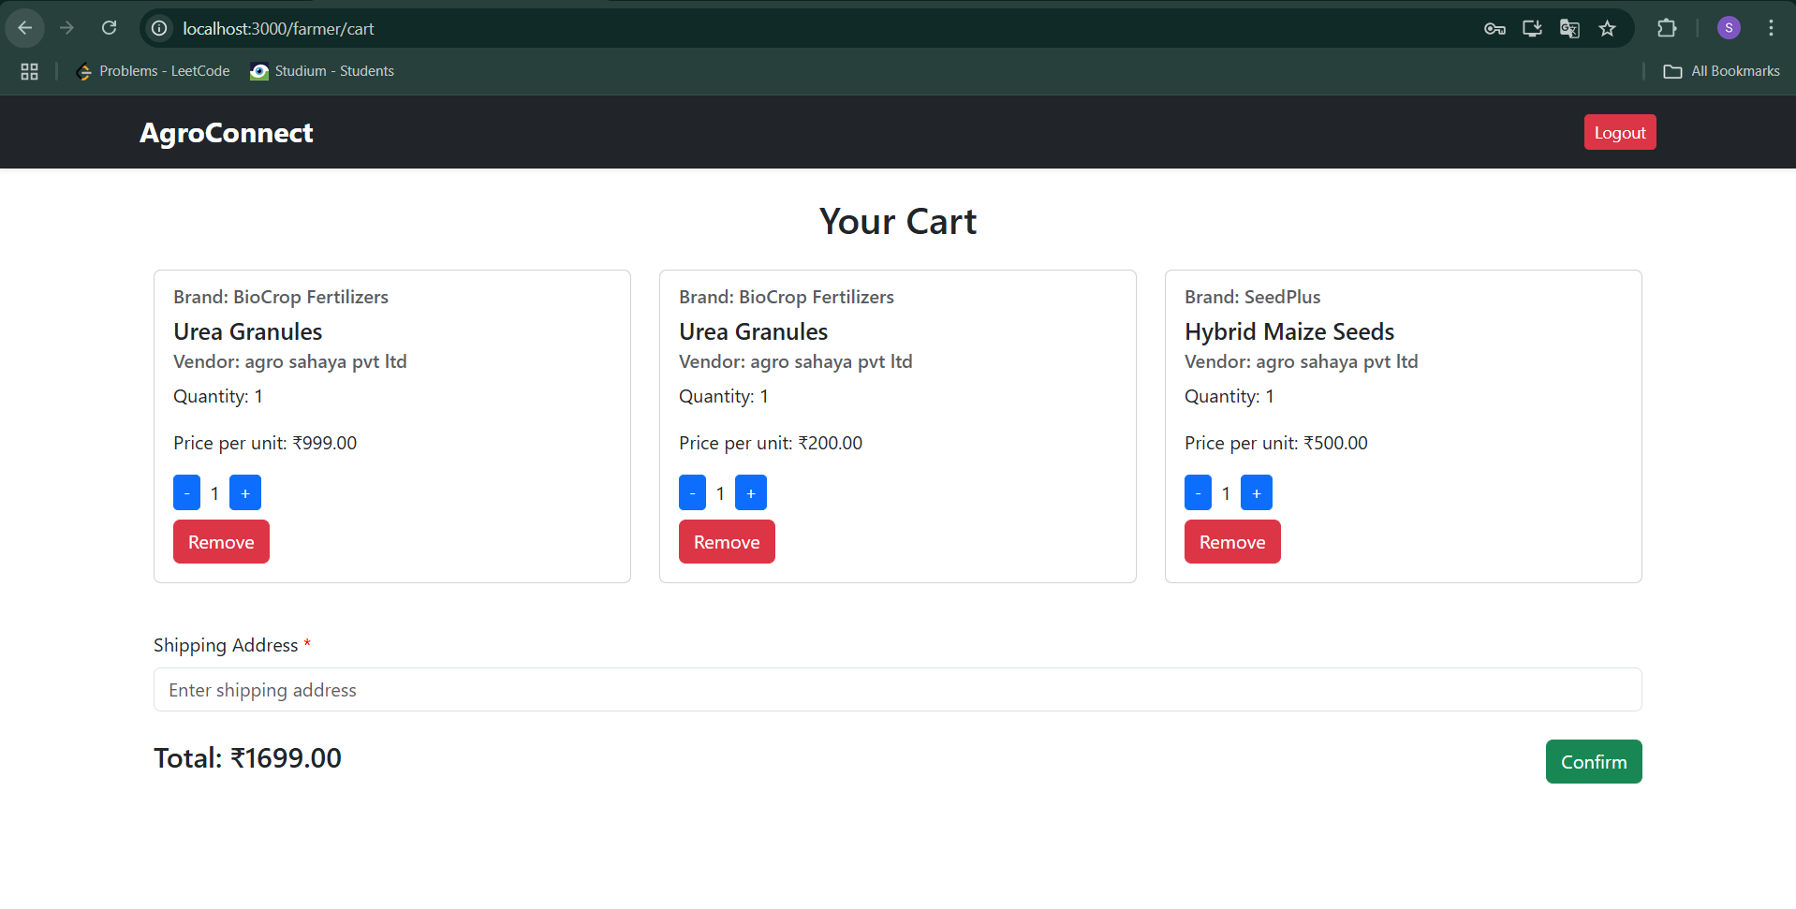

In order view :

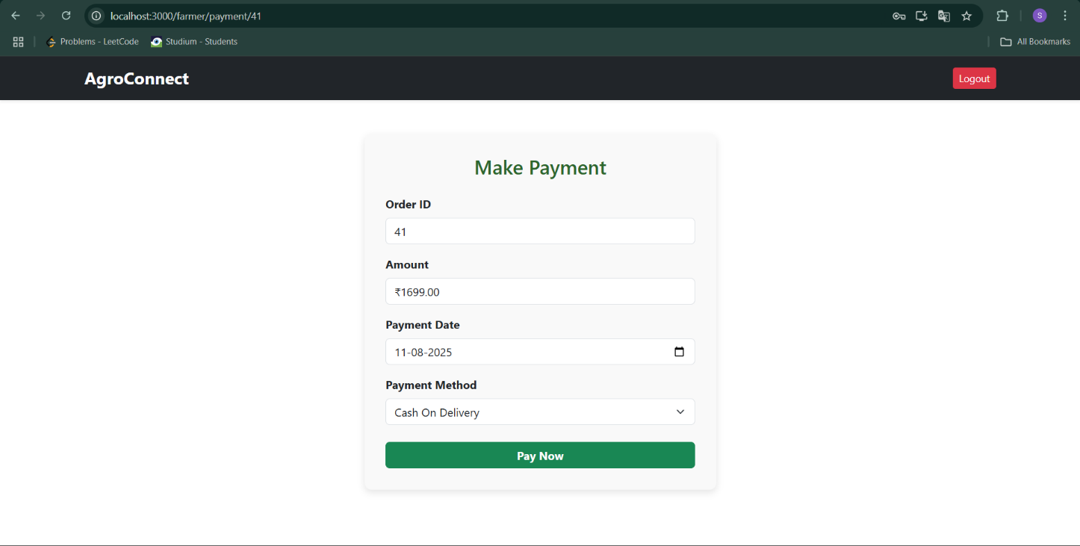

In orders and payment :

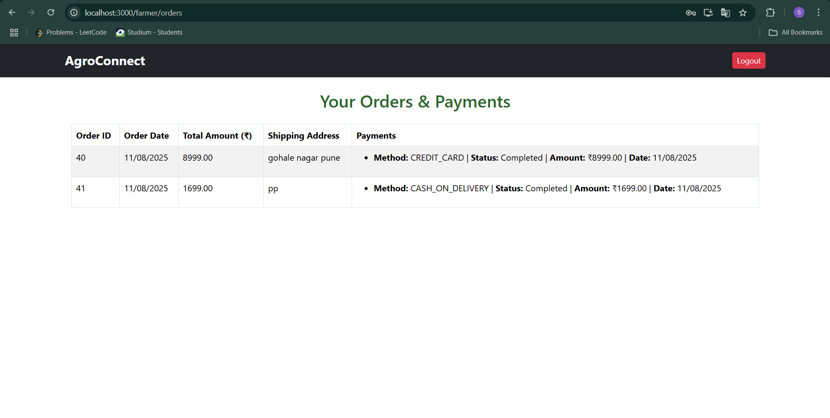

In view schemes:

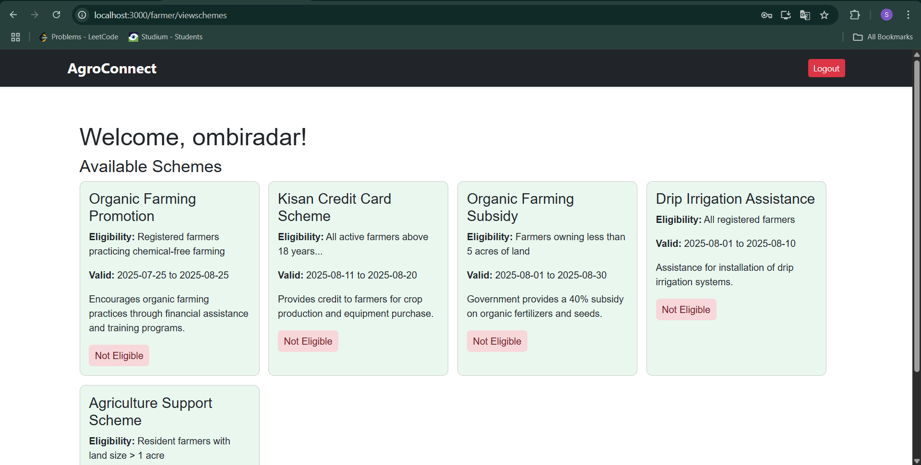

**8.5 Government**

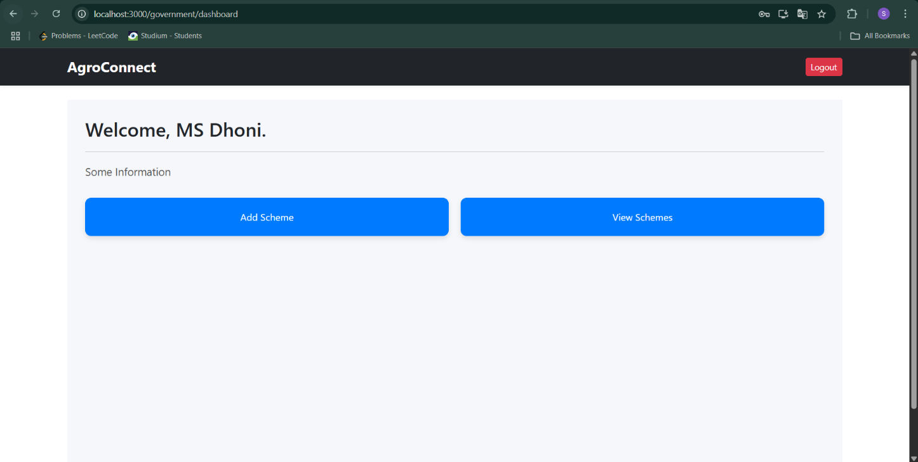

In add Schemes:

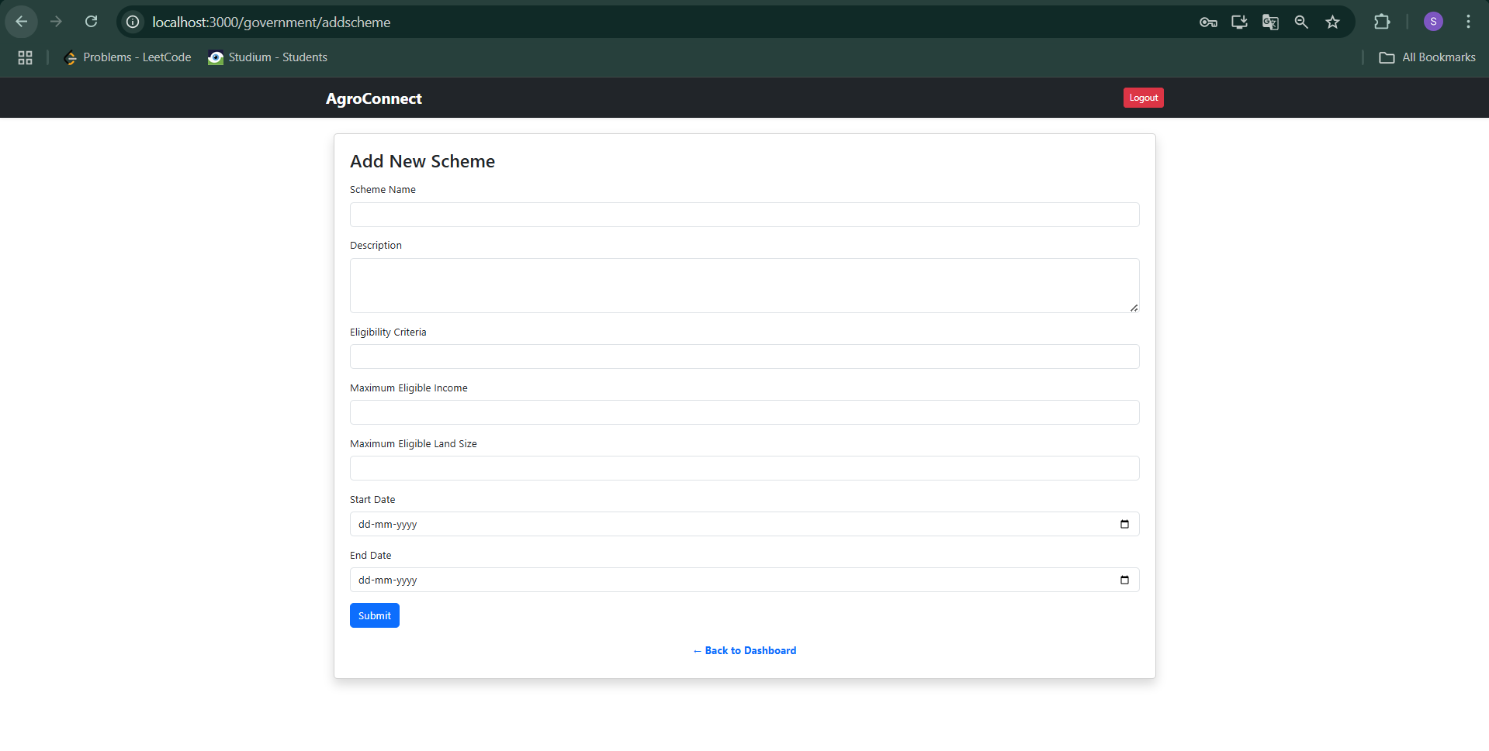

View all Schemes:

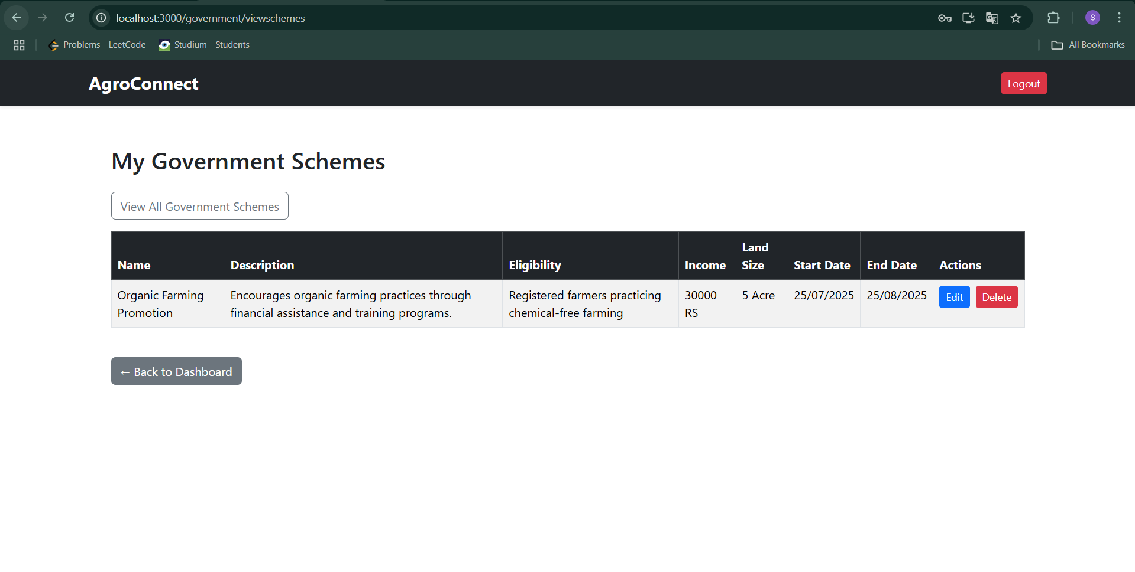

**8.5 Vendor**

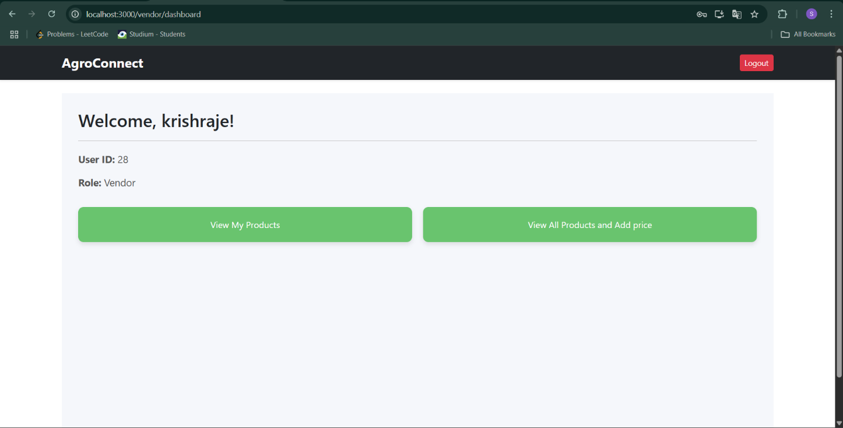

In view products and add delete price:

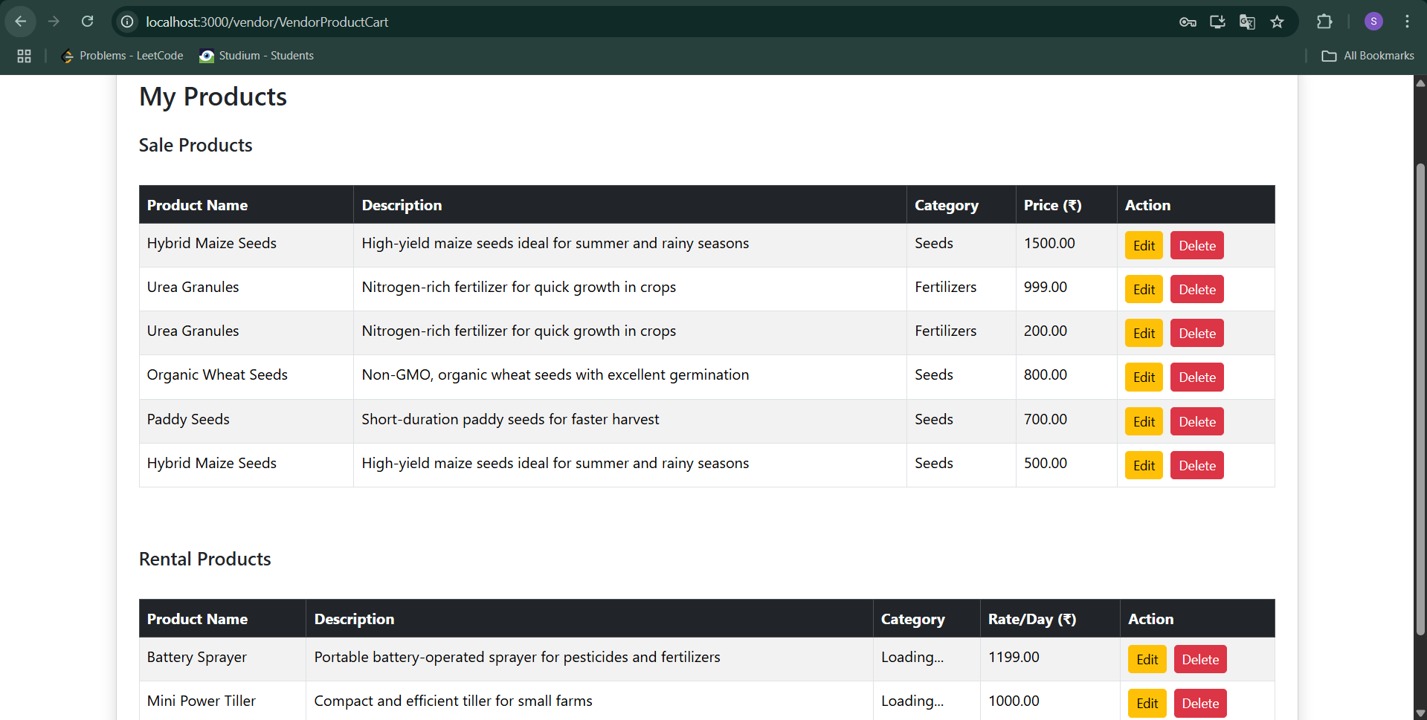

In adding price of products:

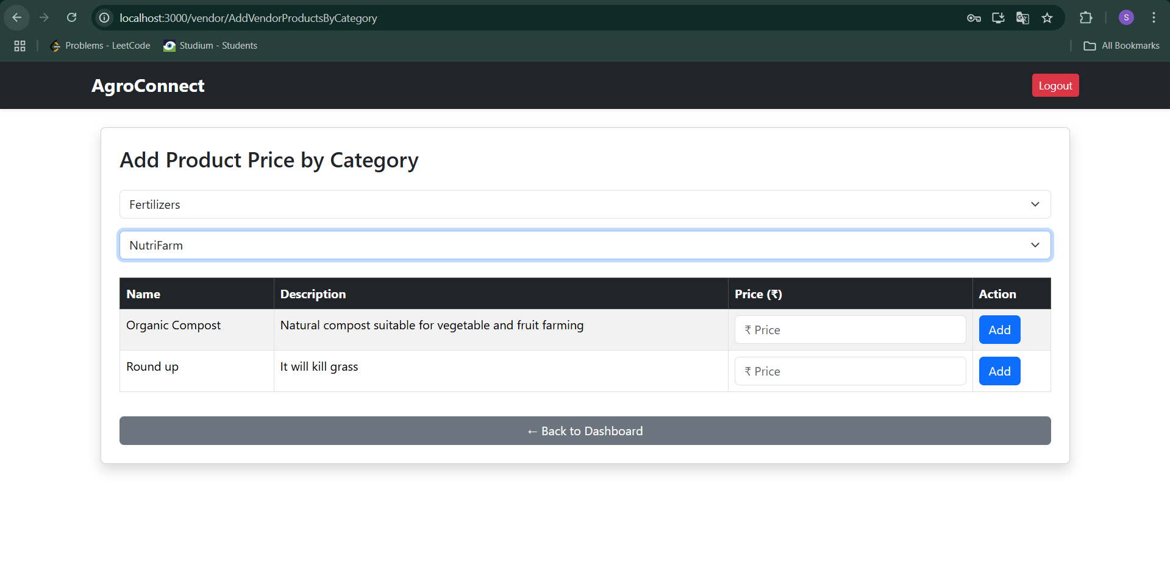

**9. ER Diagram**

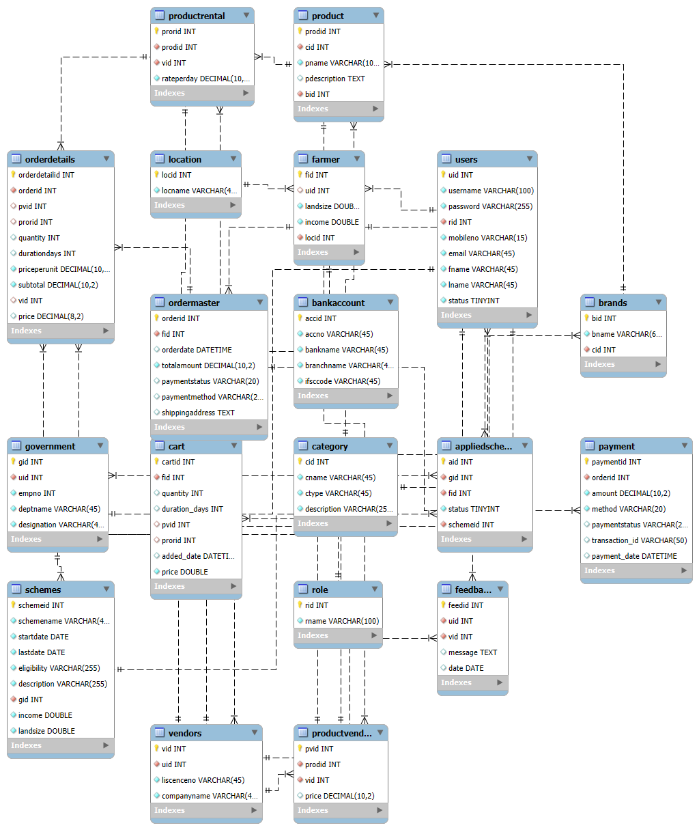

# Conclusion

The “AgroConnect – Farmer Support System” aims to provide a centralized and user-friendly platform that connects farmers with government schemes, vendors, and agricultural resources. By integrating scheme management, eligibility verification, vendor marketplace.The application empowers farmers to access benefits, improve productivity, and make informed decisions. With a farmer-friendly interface, secure data handling, and continuous enhancements, AgroConnect seeks to be a valuable tool in strengthening the agricultural ecosystem and supporting rural development.